1.#include <stdio.h>
#include <unistd.h>
#include <sys/wait.h>

int main(void)
{
pid_t pid = fork();

if (pid < 0) {
perror("fork");
return 1;
}

if (pid == 0) {
printf("Child PID: %d\n", getpid());
printf("Parent PID: %d\n", getppid());
execlp("ls", "ls", "-l", NULL);
perror("execlp");
return 1;
}

waitpid(pid, NULL, 0);
printf("Parent PID: %d - child completed\n", getpid());
return 0;
}
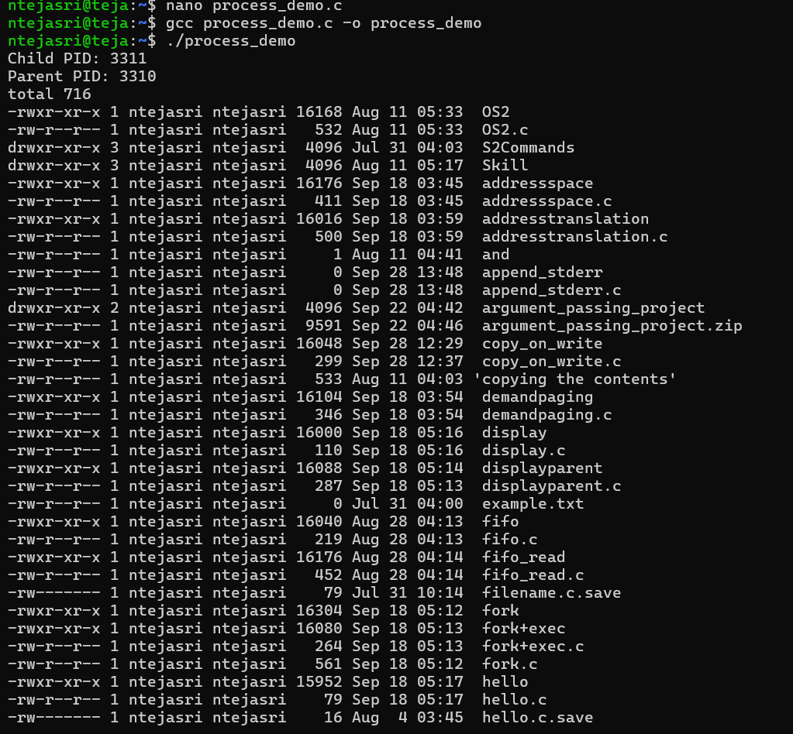
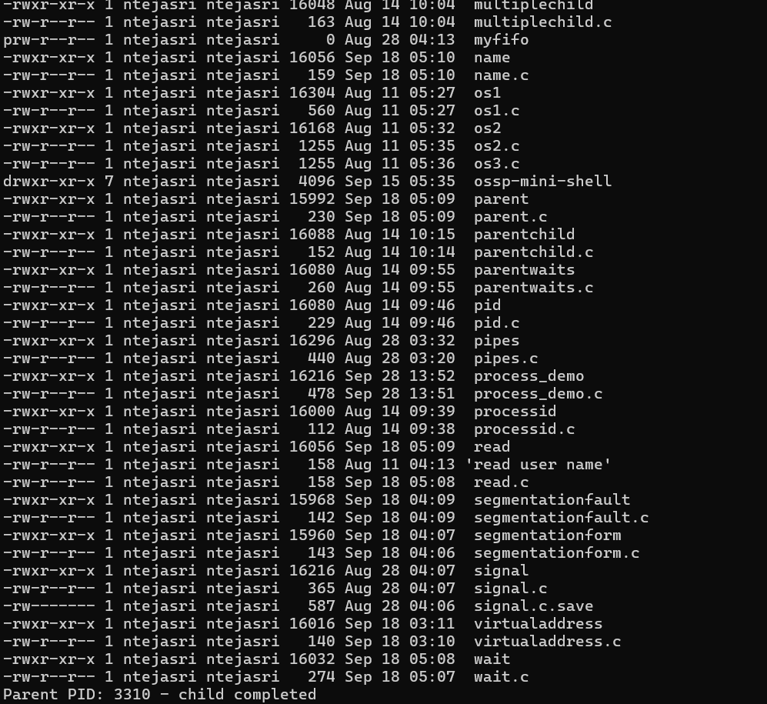
2.#include <stdio.h>
#include <string.h>

int main(void)
{
char input[200];

while (1) {
printf("myshell> ");
fflush(stdout);

if (fgets(input, sizeof(input), stdin) == NULL)
break;

input[strcspn(input, "\n")] = '\0';

if (strcmp(input, "exit") == 0)
break;

if (input[0] != '\0')
printf("Command entered: %s\n", input);
}

return 0;
}
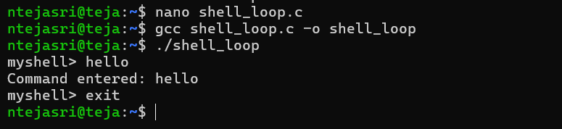
3.#include <stdio.h>
#include <stdlib.h>
#include <string.h>

int main(void)
{
char **history = NULL;
size_t capacity = 2, count = 0;
char input[200];

history = malloc(capacity * sizeof(*history));
if (!history) {
perror("malloc");
return 1;
}

while (1) {
printf("myshell> ");
fflush(stdout);

if (!fgets(input, sizeof(input), stdin))
break;

input[strcspn(input, "\n")] = '\0';

if (strcmp(input, "exit") == 0)
break;

if (count == capacity) {
capacity *= 2;
char **tmp = realloc(history, capacity * sizeof(*history));
if (!tmp) {
perror("realloc");
break;
}
history = tmp;
}

history[count] = malloc(strlen(input) + 1);
if (!history[count]) {
perror("malloc");
break;
}

strcpy(history[count], input);
count++;
}

printf("\nHistory:\n");
for (size_t i = 0; i < count; i++) {
printf("%zu: %s\n", i + 1, history[i]);
free(history[i]);
}

free(history);
return 0;
}
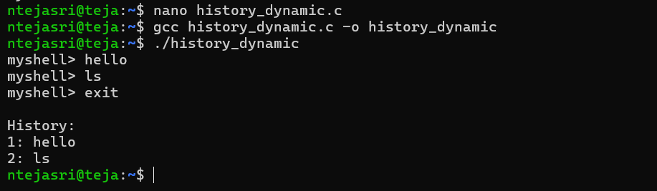
4.#include <stdio.h>
#include <string.h>

int main(void)
{
char input[200];

printf("Enter command: ");
if (!fgets(input, sizeof(input), stdin))
return 1;

char *token = strtok(input, " \t\n");
int count = 0;

while (token) {
printf("Token %d: %s\n", ++count, token);
token = strtok(NULL, " \t\n");
}

if (count == 0)
printf("Empty command\n");

return 0;
}
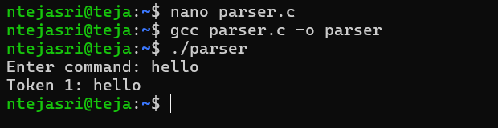
5.#include <stdio.h>
#include <string.h>

int main(void)
{
char input[300];

printf("Enter text containing quotes: ");
if (!fgets(input, sizeof(input), stdin))
return 1;

input[strcspn(input, "\n")] = '\0';

printf("Input: %s\n", input);
printf("Single quotes preserve literal text; double quotes preserve spaces and may allow expansion in a shell.\n");

return 0;
}
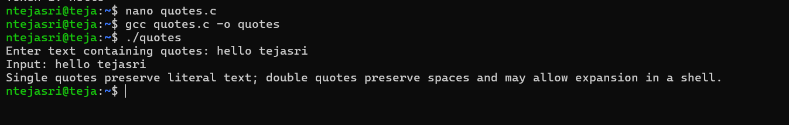
6.#include <stdio.h>
#include <unistd.h>

int main(void)
{
printf("Executing: echo Hello World\n");

execlp("echo", "echo", "Hello", "World", NULL);

perror("execlp");
return 1;
}
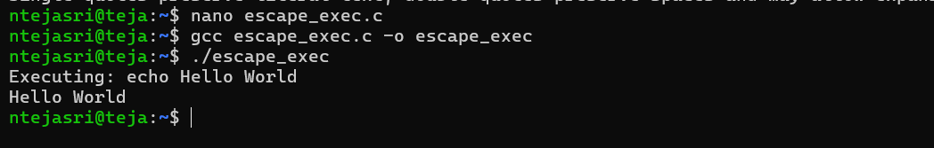
7.#include <stdio.h>
#include <stdlib.h>
#include <unistd.h>
#include <sys/wait.h>

int main(void)
{
char *path = getenv("PATH");
if (path)
printf("PATH = %s\n", path);

pid_t pid = fork();

if (pid < 0) {
perror("fork");
return 1;
}

if (pid == 0) {
printf("Child running...\n");
sleep(1);
_exit(0);
}

int status;
waitpid(pid, &status, 0);

if (WIFEXITED(status))
printf("Parent: child exited with status %d\n", WEXITSTATUS(status));

return 0;
}
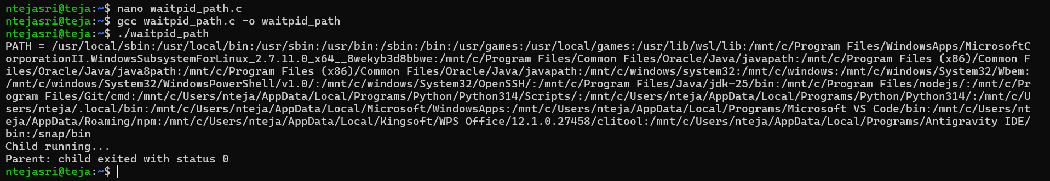
8.#include <stdio.h>
#include <stdlib.h>
#include <string.h>

int main(void)
{
char input[200];

printf("Enter variable name (example: HOME): ");
if (!fgets(input, sizeof(input), stdin))
return 1;

input[strcspn(input, "\n")] = '\0';

char *value = getenv(input);

if (value)
printf("%s = %s\n", input, value);
else
printf("Variable is undefined.\n");

return 0;
}
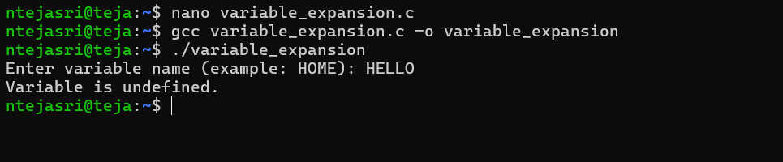
9.#include <stdio.h>
#include <string.h>

void cmd_pwd(void) { printf("Built-in: pwd\n"); }
void cmd_cd(void) { printf("Built-in: cd\n"); }
void cmd_exit(void) { printf("Built-in: exit\n"); }

int main(void)
{
char command[50];

printf("Enter built-in command: ");
scanf("%49s", command);

if (strcmp(command, "pwd") == 0)
cmd_pwd();
else if (strcmp(command, "cd") == 0)
cmd_cd();
else if (strcmp(command, "exit") == 0)
cmd_exit();
else
printf("Unknown command\n");

return 0;
}
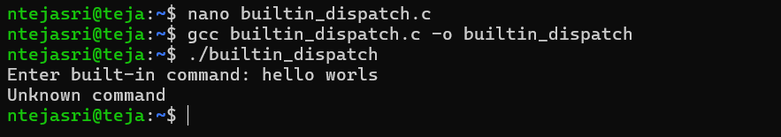
10.#include <stdio.h>
#include <stdlib.h>
#include <string.h>
#include <unistd.h>

int main(void)
{
char command[200];

while (1) {
printf("myshell> ");
fflush(stdout);

if (!fgets(command, sizeof(command), stdin))
break;

command[strcspn(command, "\n")] = '\0';

if (strcmp(command, "pwd") == 0) {
char path[512];
if (getcwd(path, sizeof(path)))
printf("%s\n", path);
}
else if (strncmp(command, "cd ", 3) == 0) {
if (chdir(command + 3) != 0)
perror("cd");
}
else if (strncmp(command, "export ", 7) == 0) {
char *eq = strchr(command + 7, '=');
if (eq) {
*eq = '\0';
setenv(command + 7, eq + 1, 1);
} else {
printf("Use: export NAME=value\n");
}
}
else if (strcmp(command, "exit") == 0) {
break;
}
else {
printf("Unknown built-in command\n");
}
}

return 0;
}
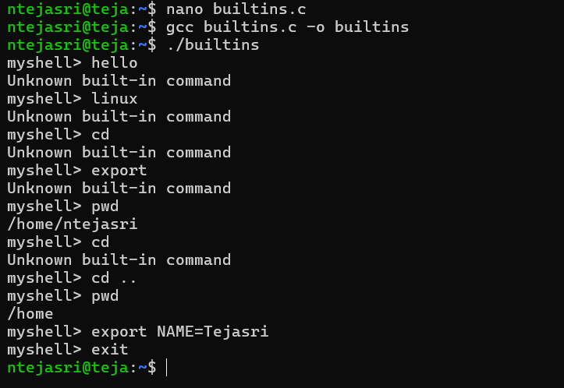
11.#include <stdio.h>
#include <string.h>

int main(void)
{
char *commands[3] = {"ls", "grep main", "wc -l"};
int count = 3;

printf("Command History:\n");
for (int i = 0; i < count; i++)
printf("%d: %s\n", i + 1, commands[i]);

printf("\nPipeline structure:\n");
printf("ls | grep main | wc -l\n");

return 0;
}
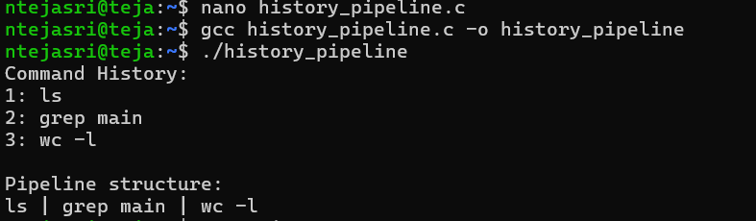
12.#include <stdio.h>
#include <unistd.h>
#include <string.h>
#include <sys/wait.h>

int main(void)
{
int fd[2];
pipe(fd);

pid_t pid = fork();

if (pid == 0) {
char buffer[100];
close(fd[1]);
read(fd[0], buffer, sizeof(buffer));
printf("Child received: %s\n", buffer);
close(fd[0]);
} else {
char message[] = "Hello through pipe";
close(fd[0]);
write(fd[1], message, strlen(message) + 1);
close(fd[1]);
waitpid(pid, NULL, 0);
}

return 0;
}
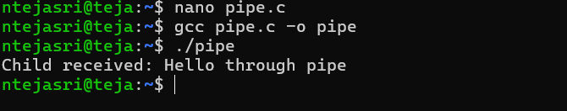
13.#include <stdio.h>
#include <fcntl.h>
#include <unistd.h>

int main(void)
{
int fd = open("input.txt", O_RDONLY);
if (fd < 0) {
perror("input.txt");
return 1;
}

dup2(fd, STDIN_FILENO);
close(fd);

char buffer[200];
ssize_t n = read(STDIN_FILENO, buffer, sizeof(buffer) - 1);

if (n > 0) {
buffer[n] = '\0';
printf("Read from redirected stdin:\n%s", buffer);
}

return 0;
}
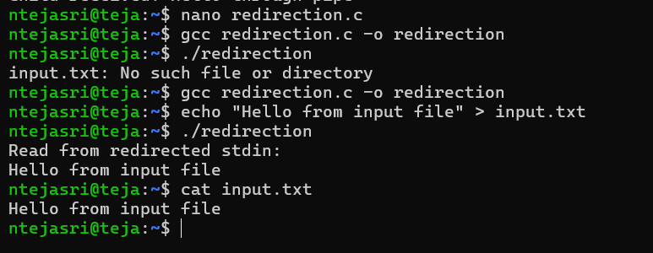
14.#include <stdio.h>
#include <fcntl.h>
#include <unistd.h>

int main(void)
{
int fd = open("log.txt", O_WRONLY | O_CREAT | O_APPEND, 0644);
if (fd < 0) {
perror("open");
return 1;
}

dup2(fd, STDOUT_FILENO);
close(fd);

printf("This line is appended to log.txt\n");

fprintf(stderr, "This is an error message on stderr.\n");

return 0;
}
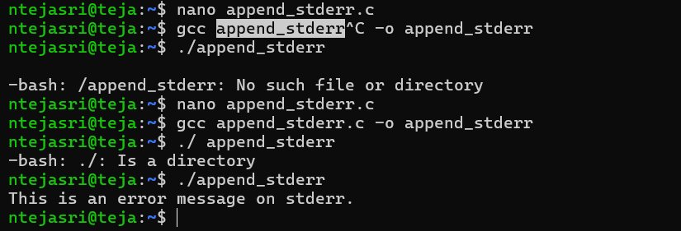
15.#include <stdio.h>
#include <unistd.h>
#include <fcntl.h>
#include <sys/wait.h>

int main(void)
{
int pipefd[2];
pipe(pipefd);

pid_t pid = fork();

if (pid == 0) {
dup2(pipefd[1], STDOUT_FILENO);
close(pipefd[0]);
close(pipefd[1]);

execlp("ls", "ls", NULL);
perror("ls");
_exit(1);
}

int out = open("result.txt", O_WRONLY | O_CREAT | O_TRUNC, 0644);
dup2(pipefd[0], STDIN_FILENO);
dup2(out, STDOUT_FILENO);

close(pipefd[0]);
close(pipefd[1]);
close(out);

waitpid(pid, NULL, 0);
execlp("wc", "wc", "-l", NULL);

perror("wc");
return 1;
}
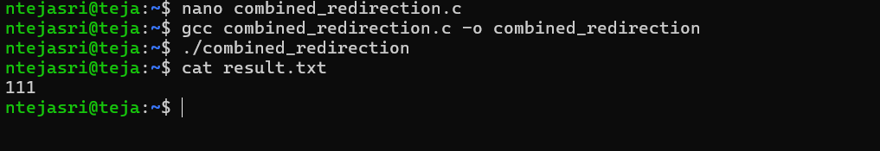
16.#include <stdio.h>
#include <unistd.h>
#include <sys/wait.h>

int main(void)
{
pid_t pid = fork();

if (pid == 0) {
printf("Background job PID: %d\n", getpid());
sleep(5);
printf("Background job finished.\n");
_exit(0);
}

printf("Parent returns immediately. Job PID: %d\n", pid);
sleep(1);

return 0;
}
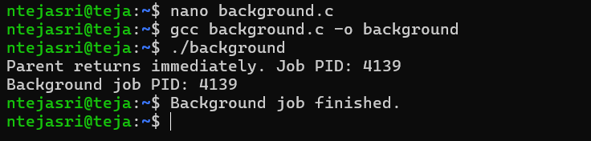
17.#include <stdio.h>
#include <unistd.h>
#include <sys/wait.h>

int main(void)
{
pid_t pid = fork();

if (pid == 0) {
printf("Foreground job PID: %d\n", getpid());
sleep(3);
printf("Job completed.\n");
_exit(0);
}

printf("[1] %d running\n", pid);
printf("Waiting for foreground job...\n");
waitpid(pid, NULL, 0);
printf("[1] done\n");

return 0;
}
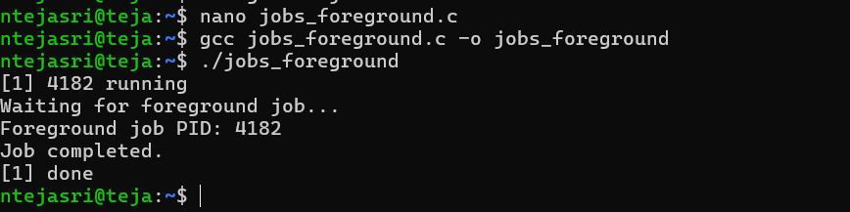
18.#include <stdio.h>
#include <signal.h>
#include <unistd.h>
#include <sys/wait.h>

int main(void)
{
pid_t pid = fork();

if (pid == 0) {
printf("Child PID %d running\n", getpid());
raise(SIGSTOP);
printf("Child resumed after SIGCONT\n");
_exit(0);
}

int status;
waitpid(pid, &status, WUNTRACED);

if (WIFSTOPPED(status))
printf("Parent: child stopped by signal %d\n", WSTOPSIG(status));

sleep(1);
kill(pid, SIGCONT);
printf("Parent: SIGCONT sent\n");

waitpid(pid, &status, 0);
printf("Parent: child completed\n");

return 0;
}
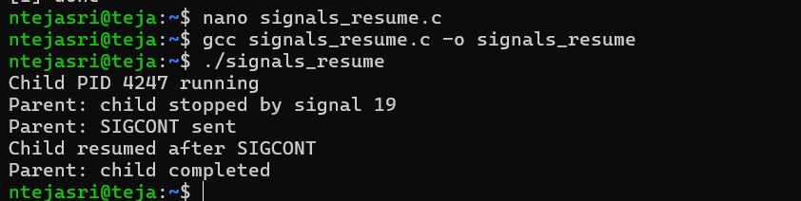
19.#include <stdio.h>
#include <signal.h>
#include <unistd.h>

volatile sig_atomic_t running = 1;

void handle_sigint(int sig)
{
(void)sig;
running = 0;
}

int main(void)
{
signal(SIGINT, handle_sigint);

printf("Running. Press Ctrl+C to stop.\n");

while (running) {
printf("Working...\n");
sleep(1);
}

printf("SIGINT handled. Exiting safely.\n");
return 0;
}
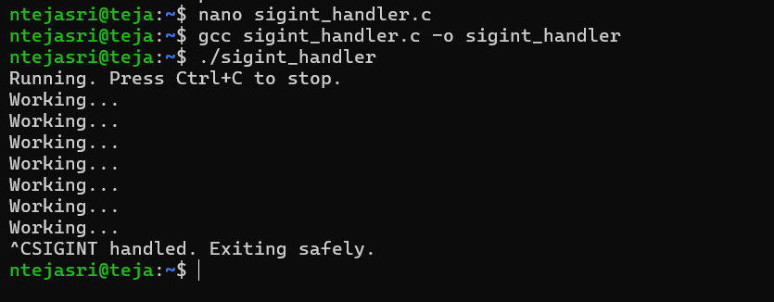
20.#include <stdio.h>
#include <signal.h>
#include <unistd.h>

void handle_sigtstp(int sig)
{
(void)sig;
printf("\nSIGTSTP received. Handler executed.\n");
}

int main(void)
{
printf("PID: %d, Process Group ID: %d\n", getpid(), getpgrp());

signal(SIGTSTP, handle_sigtstp);

printf("Press Ctrl+Z to send SIGTSTP.\n");

while (1)
sleep(2);

return 0;
}
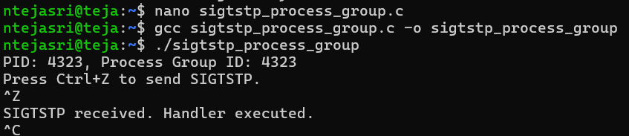
21.#include <stdio.h>
#include <fcntl.h>
#include <errno.h>
#include <string.h>
#include <unistd.h>

int main(void)
{
int fd = open("missing_file.txt", O_RDONLY);

if (fd == -1) {
fprintf(stderr, "Runtime error: %s\n", strerror(errno));
return 1;
}

close(fd);
return 0;
}
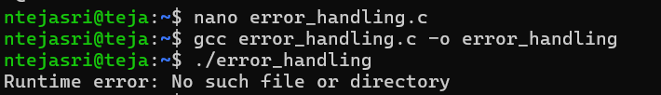
22.#include <stdio.h>
#include <stdlib.h>

int main(void)
{
int *a = malloc(5 * sizeof(int));
int *b = calloc(5, sizeof(int));

if (!a || !b) {
free(a);
free(b);
return 1;
}

a = realloc(a, 10 * sizeof(int));

if (!a) {
free(b);
return 1;
}

free(a);
free(b);

printf("Memory allocated and freed successfully.\n");
return 0;
}
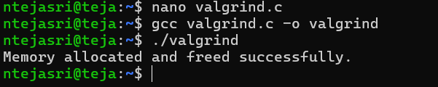
23.#include <stdio.h>
#include <unistd.h>
#include <sys/wait.h>

int main(void)
{
int p1[2], p2[2];
pipe(p1);
pipe(p2);

pid_t c1 = fork();

if (c1 == 0) {
dup2(p1[1], STDOUT_FILENO);
close(p1[0]); close(p1[1]);
close(p2[0]); close(p2[1]);
execlp("ps", "ps", "-e", NULL);
_exit(1);
}

pid_t c2 = fork();

if (c2 == 0) {
dup2(p1[0], STDIN_FILENO);
dup2(p2[1], STDOUT_FILENO);
close(p1[0]); close(p1[1]);
close(p2[0]); close(p2[1]);
execlp("grep", "grep", "bash", NULL);
_exit(1);
}

close(p1[0]); close(p1[1]);

pid_t c3 = fork();

if (c3 == 0) {
dup2(p2[0], STDIN_FILENO);
close(p2[0]); close(p2[1]);
execlp("wc", "wc", "-l", NULL);
_exit(1);
}

close(p2[0]); close(p2[1]);

waitpid(c1, NULL, 0);
waitpid(c2, NULL, 0);
waitpid(c3, NULL, 0);

return 0;
}
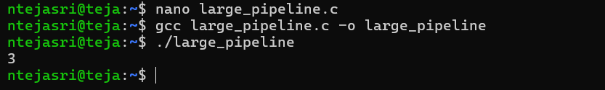
24.#include <stdio.h>
#include <unistd.h>
#include <signal.h>
#include <sys/wait.h>

void handle_sigint(int sig)
{
(void)sig;
printf("Signal received.\n");
}

int main(void)
{
int pipefd[2];
pipe(pipefd);

signal(SIGINT, handle_sigint);

pid_t pid = fork();

if (pid == 0) {
char buffer[100];

close(pipefd[1]);
read(pipefd[0], buffer, sizeof(buffer));
printf("Child received: %s\n", buffer);
close(pipefd[0]);
} else {
char message[] = "Final OSSP demonstration";

close(pipefd[0]);
write(pipefd[1], message, sizeof(message));
close(pipefd[1]);

waitpid(pid, NULL, 0);
printf("Parent: child completed.\n");
}

return 0;
}
